**COM 321**

**GUIDED TRANSMISSION MEDIA**

* The purpose of the physical layer is to transport bits from one machine to another
* Transmission media that rely on a physical cable or wire are often called **guided transmission** media because the signal transmissions are guided along a path with a physical cable or wire.
* The most common guided transmission media are :

1. copper cable(in the form of coaxial cable or twisted pair)
2. fiber optics

* Each type of guided transmission media has its own set of trade-offs in terms of **frequency**, **bandwidth**, **delay**, **cost**, and **ease of installation and maintenance**
* **Bandwidth** is a measure of the carrying capacity of a medium. It is measured in **Hz** (or **MHz** or **GHz**). It is named in honor of the German physicist Heinrich Hertz

**Persistent Storage**

* One of the most common ways to transport data from one device to another is to write them onto persistent storage, such as magnetic or solid-state storage (e.g., recordable DVDs), physically transport the tape or disks to the destination machine, and read them back in again
* This method is not as sophisticated as using a geosynchronous communication satellite, it is often more cost effective, especially for applications where a high data rate or cost per bit transported is the key factor.

**Twisted Pairs**

* A twisted pair consists of two insulated copper wires, typically about 1 mm thick. The wires are twisted together in a helical form, similar to a DNA molecule
* Two parallel wires constitute a fine antenna; when the wires are twisted, the waves from different twists cancel out, so the wire radiates less effectively. A signal is usually carried as the difference in voltage between the two wires in the pair. Transmitting the signal as the difference between the two voltage levels, as opposed to an absolute voltage, provides better immunity to external noise because the noise tends to affect the voltage traveling through both wires in the same way, leaving the differential relatively unchanged
* The most common application of the twisted pair is the telephone system.
* Twisted pairs can run several kilometers without amplification, but for longer distances the signal becomes too attenuated and repeaters are needed.
* When many twisted pairs run in parallel for a substantial distance, such as all the wires coming

from an apartment building to the telephone company office, they are bundled together and encased in a protective sheath.

* The pairs in these bundles would interfere with one another if it were not for the twisting
* Twisted pairs can be used for transmitting either analog or digital information
* The bandwidth depends on the thickness of the wire and the distance traveled, but hundreds of megabits/sec can be achieved for a few kilometers, in many cases, and more when various tricks are used.
* Due to their adequate performance, widespread availability, and low cost, twisted pairs are widely used and are likely to remain so for years to come.
* Twisted-pair cabling comes in several varieties. One common variety of twisted-pair cables now deployed in many buildings is called **Category 5e** cabling, or **“Cat 5e”.**
* A Category 5e twisted pair consists of two insulated wires gently twisted together. Four such pairs are typically grouped in a plastic sheath to protect the wires and keep them together. This arrangement is shown in Figure below.

Category 5e **UTP** cable with four twisted pairs. These cables can be

used for local area networks.

* Different LAN standards may use the twisted pairs differently. For example, 100-Mbps Ethernet uses two (out of the four) pairs, one pair for each direction.
* To reach higher speeds, 1-Gbps Ethernet uses all four pairs in both directions simultaneously, which requires the receiver to factor out the signal that is transmitted.
* Links that can be used in both directions at the same time, like a two-lane road, are called **full- duplex** links.
* In contrast, links that can be used in either direction, but only one way at a time, like a single-track railroad line, are called **half-duplex** links.
* A third category consists of links that allow traffic in only one direction, like a one-way street. They are called **simplex links**.
* Returning to twisted pair, **Cat 5** replaced earlier **Category 3** cables with a similar cable that uses the same connector, but has more twists per meter.
* More twists result in less crosstalk and a better-quality signal over longer distances, making the

cables more suitable for high-speed computer communication, especially 100-Mbps and 1-Gbps Ethernet LANs.

* **Category 8** wiring runs at higher speeds than the lower categories, but operates only at short distances of around 30 meters and is thus only suitable in data centers
* he Category 8 standard has two options: Class I, which is compatible with Category 6A; and Class II, which is compatible with Category 7A.
* Through Category 6, these wiring types are referred to as **UTP (Unshielded Twisted Pair)** as they consist simply of wires and insulators.
* In contrast to these, Category 7 cables have shielding on the individual twisted pairs, as well as around the entire cable (but inside the plastic protective sheath).
* Shielding reduces the susceptibility to external interference and crosstalk with other nearby cables to meet demanding performance specifications.

**Coaxial Cable**

* Another common transmission medium is the **coaxial cable**
* It has better shielding and greater bandwidth than unshielded twisted pairs, so it can span longer distances at higher speeds.
* Two kinds of coaxial cable are widely used:

1. 50-ohm cable, is commonly used when it is intended for digital transmission from the start.
2. 75-ohm cable, is commonly used for analog transmission and cable television.

* This distinction is based on historical, rather than technical, factors.
* A coaxial cable consists of a stiff copper wire as the core, surrounded by an insulating material.
* The insulator is encased by a cylindrical conductor, often as a closely woven braided mesh.
* The outer conductor is covered in a protective plastic sheath.

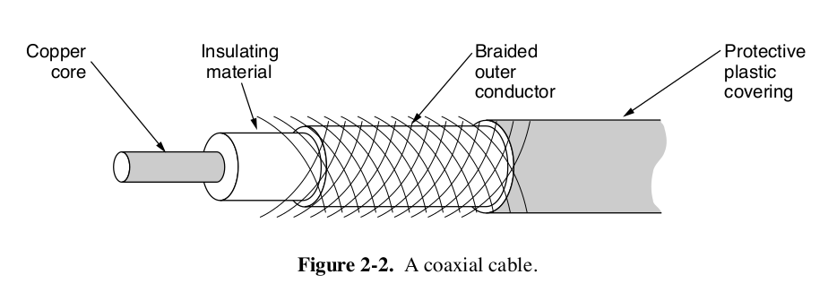**A cutaway view of a coaxial cable is shown in figure below.**

* The construction and shielding of the coaxial cable give it a good combination of high bandwidth and excellent noise immunity (e.g., from garage door openers, microwave ovens, and more).
* The bandwidth possible depends on the cable quality and length.
* Coaxial cable has extremely wide bandwidth; modern cables have a bandwidth of up to 6 GHz, thus allowing many conversations to be simultaneously transmitted over a single coaxial cable (a single television program might occupy approximately 3.5 MHz).
* Coaxial cables were once widely used within the telephone system for long-distance lines but have now largely been replaced by fiber optics on long-haul routes.
* Coax is still widely used for cable television and metropolitan area networks and is also used for delivering high-speed Internet connectivity to homes in many parts of the world.

**Power Lines**

* The telephone and cable television networks are not the only sources of wiring that can be reused for data communication.
* Power lines have been used by electricity companies for low-rate communication such as remote metering for many years, as well in the home to control devices (e.g., the X10 standard).
* In recent years there has been renewed interest in high-rate communication over these lines, both inside the home as a LAN and outside the home for broadband Internet access.
* The convenience of using power lines for networking should be clear. Simply plug a TV and a receiver into the wall, which you must do anyway because they need power, and they can send and receive movies over the electrical wiring.
* This configuration is shown in Figure below.
* There is no other plug or radio. The data signal is superimposed on the low-frequency power signal (on the active or ‘‘hot’’ wire) as both signals use the wiring at the same time.

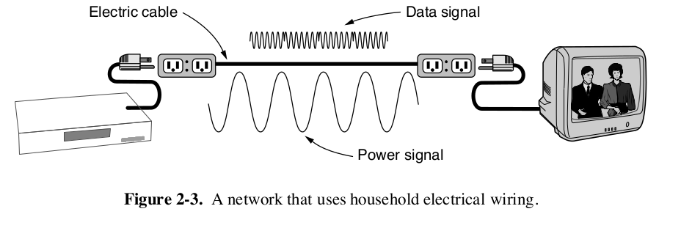

* The difficulty with using household electrical wiring for a network is that it was designed to distribute power signals. This task is quite distinct from distributing data signals, at which household wiring does a horrible job.
* The electrical properties of the wiring vary from one house to the next and change as appliances are turned on and off, which causes data signals to bounce around the wiring.
* Transient currents when appliances switch on and off create electrical noise over a wide range of frequencies.
* without the careful twisting of twisted pairs, electrical wiring acts as a fine antenna, picking up external signals and radiating signals of its own
* This behavior means that to meet regulatory requirements, the data signal must avoid licensed frequencies such as the amateur radio bands.
* Despite these difficulties, it is practical to send at least 500 Mbps short distances over typical household electrical wiring by using communication schemes that resist impaired frequencies and bursts of errors.

**Fiber Optics**

* Fiber optics are used for long-haul transmission in network backbones, high speed LANs (although so far, copper has often managed to catch up eventually), and high-speed Internet access such as fiber to the home.
* An optical transmission system has three key components:

1. the light source
2. the transmission medium
3. the detector.

* Conventionally, a pulse of light indicates a 1 bit and the absence of light indicates a 0 bit.
* The transmission medium is an ultra-thin fiber of glass.
* The detector generates an electrical pulse when light falls on it.
* By attaching a light source to one end of an optical fiber and a detector to the other, we have a unidirectional (i.e., simplex) data transmission system that accepts an electrical signal, converts and transmits it by light pulses, and then reconverts the output to an electrical signal at the receiving end.
* This transmission system would leak light and be useless in practice were it not for an interesting principle of physics.
* When a light ray passes from one medium to another—for example, from fused silica (glass) to air—the ray is refracted (bent) at the silica/air boundary, as shown in Fig. 2-4(a).
* Here we see a light ray incident on the boundary at an angle _ 1 emerging at an angle ` 1. The amount of refraction depends on the properties of the two media (in particular, their indices of refraction).
* For angles of incidence above a certain critical value, the light is refracted back into the silica; none of it escapes into the air. Thus, a
* light ray incident at or above the critical angle is trapped inside the fiber, as shownin Fig. 2-4(b), and can propagate for many kilometers with virtually no loss.

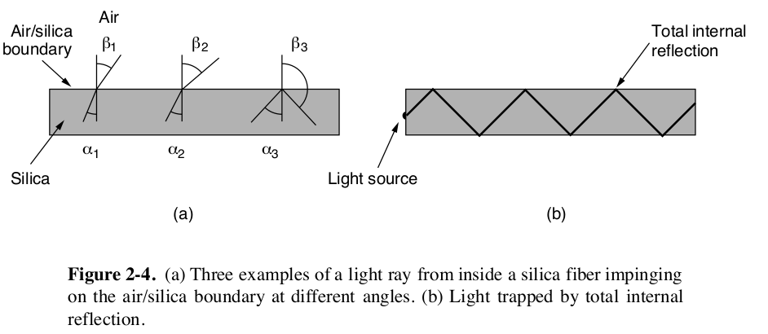

* The sketch of Fig. 2-4(b) shows only one trapped ray, but since any light ray incident on the boundary above the critical angle will be reflected internally, many different rays will be bouncing around at different angles. Each ray is said to have a different mode, so a fiber having this property is called a **multimode fiber**.
* If the fiber’s diameter is reduced to a few wavelengths of light (less than 10 microns, as opposed to more than 50 microns for multimode fiber), the fiber acts like a waveguide and the light can propagate only in a straight line, without bouncing, yielding a **single-mode fiber**.
* Single-mode fibers are more expensive but are widely used for longer distances; they can transmit signals approximately 50 times further than multimode fibers.
* Currently available single-mode fibers can transmit data at 100 Gbps for 100 km without amplification.
* Even higher data rates have been achieved in the laboratory for shorter distances. The choice between **single-mode** or **multimode fiber** depends on the application.
* Multimode fiber can be used for transmissions of up to about 15 km and can allow the use of relatively less expensive fiber-optic equipment. On the other hand, the bandwidth of multimode

fiber becomes more limited as distance increases.

**Transmission of Light Through Fiber**

* The attenuation of light through glass depends on the wavelength of the light (as well as on some of the physical properties of the glass).It is defined as the ratio of input to output signal power.
* For the kind of glass used in fibers, the attenuation is shown in units of decibels (dB) per linear kilometer of fiber.
* As an example, a factor of two loss of signal power corresponds to an attenuation of 10 log10 2 = 3 dB.
* Decibel is a logarithmic way to measure power ratios, with 3 dB meaning a factor of two power ratio.
* Visible light has slightly shorter wavelengths, from about 0.4 to 0.7 microns. (1 micron is

10-6 meters.) The true metric purist would refer to these wavelengths as 400 nm to 700 nm, but we will stick with traditional usage.

* Three wavelength bands are most commonly used at present for optical communication.
* They are centered at 0.85, 1.30, and 1.55 microns, respectively. All three bands are 25,000 to 30,000 GHz wide.
* The 0.85-micron band was used first. It has higher attenuation and so is used for shorter distances, but at that wavelength the lasers and electronics could be made from the same material (gallium arsenide).
* The last two bands have good attenuation properties (less than 5% loss per kilometer).
* The 1.55-micron band is now widely used with erbium-doped amplifiers that work directly in the optical domain
* The spreading of light pulses sent down a fiber as they propagate is called **Chromatic dispersion.** The amount of it is wavelength dependent.
* One way to keep these spread-out pulses from overlapping is to increase the distance between them, but this can be done only by reducing the signaling rate.
* Fortunately, it has been discovered that making the pulses in a special shape related to the reciprocal of the hyperbolic cosine causes nearly all the dispersion effects to cancel out, so it is now possible to send pulses for thousands of kilometers without appreciable shape distortion.
* These pulses are called **solitons**. They are starting to be widely used in practice

**Fiber Cables**

* Fiber-optic cables are similar to coax, except without the braid. Figure 2-6(a) shows a single fiber viewed from the side. At the center is the glass core through which the light propagates.

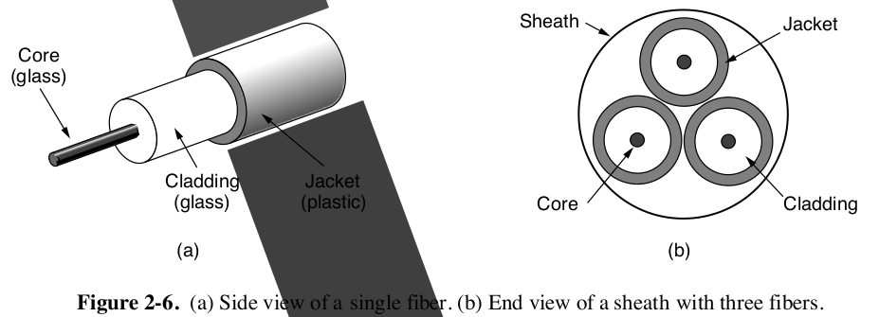

* The core is surrounded by a glass cladding with a lower index of refraction than the core, to keep all the light in the core.
* Next comes a thin plastic jacket to protect the cladding.
* Fibers are typically grouped in bundles, protected by an outer sheath. Figure 2-6(b) shows a sheath with three fibers.
* Terrestrial fiber sheaths are normally laid in the ground within a meter of the surface, where they are occasionally subject to attacks by backhoes or gophers.
* Near the shore, transoceanic fiber sheaths are buried in trenches by a kind of sea plow.
* In deep water, they just lie on the bottom, where they can be snagged by fishing trawlers or attacked by a giant squid.
* Fibers can be connected in three different ways.

1. First, they can terminate in connectors and be plugged into fiber sockets. Connectors lose about 10 to 20% of the light, but they make it easy to reconfigure systems.
2. Second, they can be spliced mechanically. Mechanical splices just lay the two carefully cut ends next to each other in a special sleeve and clamp them in place. Alignment can be improved by passing light through the junction and then making small adjustments to maximize the signal. Mechanical splices take trained personnel about 5 minutes and result in a 10% light loss.
3. Third, two pieces of fiber can be fused (melted) to form a solid connection. A fusion splice is almost as good as a single drawn fiber, but even here, a small amount of attenuation occurs. For all three kinds of splices, reflections can occur at the point of the splice and the reflected energy can interfere with the signal.

* Two kinds of light sources are typically used to do the signaling:

1. **LEDs (Light Emitting Diodes)**
2. **semiconductor lasers**.

* They have different properties, as shown in Fig. 2-7. They can be tuned in wavelength by inserting **Fabry-Perot** or **Mach-Zehnder interferometers** between the source and the fiber.
* **Fabry-Perot interferometers** are simple resonant cavities consisting of two parallel mirrors. The light is incident perpendicular to the mirrors. The length of the cavity selects out those wavelengths that fit inside an integral number of times.
* **Mach-Zehnder interferometers** separate the light into two beams. The two beams travel slightly different distances. They are recombined at the end and are in phase for only certain wavelengths.

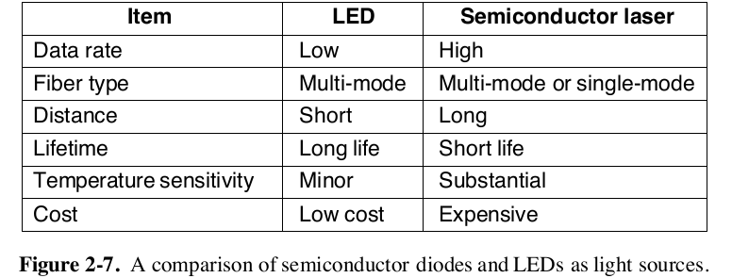

* The receiving end of an optical fiber consists of a photodiode, which gives off an electrical pulse when struck by light. The response time of photodiodes, which convert the signal from the optical to the electrical domain, limits data rates to about 100 Gbps.
* Thermal noise is also an issue, so a pulse of light must carry enough energy to be detected. By making the pulses powerful enough, the error rate can be made arbitrarily small.

**Comparison of Fiber Optics and Copper Wire**

* Fiber has many advantages.
* To start with, it can handle much higher bandwidths than copper. This alone would require its use in high-end networks.
* Due to the low attenuation, repeaters are needed only about every 50 km on long lines, versus about every 5 km for copper, resulting in a big cost saving.
* Fiber also has the advantage of not being affected by power surges, electromagnetic interference, or power failures. Nor is it affected by corrosive chemicals in the air, important for harsh factory environments.
* fiber is much lighter than copper. One thousand twisted pairs 1 km long weigh 8000 kg. Two fibers have more capacity and weigh only 100 kg, which reduces the need for expensive mechanical support systems that must be maintained.
* For new routes, fiber wins hands down due to its much lower installation cost.
* Finally, fibers do not leak light and are difficult to tap. These properties give fiber good security against wiretappers.
* **On the downside**, fiber is a less familiar technology requiring skills not all engineers have, and fibers can be damaged easily by being bent too much.
* Since optical transmission is inherently unidirectional, two-way communication requires either two fibers or two frequency bands on one fiber.
* For a discussion of many aspects of fiber optics and their networks, see Pearson (2015).

**WIRELESS TRANSMISSION**

* Wireless has advantages for even fixed devices in some circumstances. For example, if running a fiber to a building is difficult due to the terrain (mountains, jungles, swamps, etc.), wireless may be more appropriate.

**The Electromagnetic Spectrum**

* When electrons move, they create electromagnetic waves that can propagate through space (even in a vacuum).
* The number of oscillations per second of a wave is called its **frequency**, f, and is measured in Hz.
* The distance between two consecutive maxima (or minima) is called the **wavelength**, which is universally designated by the Greek letter λ (lambda).
* When an antenna of the appropriate size is attached to an electrical circuit, the electromagnetic waves can be broadcast efficiently and received by a receiver some distance away.
* All wireless communication is based on this principle.
* In a vacuum, all electromagnetic waves travel at the same speed, no matter what their frequency.
* This speed, usually called the **speed of light**, *c*, is approximately 3 × 108 m/sec, or about 1 foot (30 cm) per nanosecond.
* In copper or fiber, the speed slows to about 2/3 of this value and becomes slightly frequency dependent.
* The fundamental relation between *f* , *λ* , and *c* (in a vacuum) is

*f λ* = *c*

* Since *c* is a constant, if we know *f* , we can find *λ* , and vice versa.
* As a rule of thumb, when *λ* is in meters and *f* is in MHz, *λ* *f* ≈ 300.
* For example, 100-MHz waves are about 3 meters long, 1000-MHz waves are 0.3 meters long, and 0.1-meter waves have a frequency of 3000 MHz.
* The radio, microwave, infrared, and visible light portions of the spectrum can all be used for transmitting information by modulating the amplitude, frequency, or phase of the waves.
* Ultra-violet light, X-rays, and gamma rays would be even better, due to their higher frequencies, but they are hard to produce and modulate, do not propagate well
* through buildings, and are dangerous to living things.
* The bands listed at the bottom of Fig. 2-8 are the official ITU (International Telecommunication Union) names and are based on the wavelengths, so the LF band goes from 1 km to 10 km (approximately 30 kHz to 300 kHz).
* The terms LF, MF, and HF refer to Low, Medium, and High Frequency, respectively.

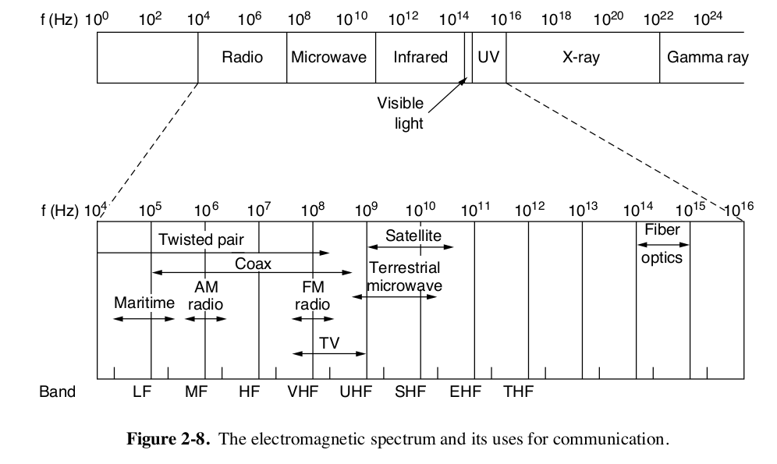

* Most transmissions use a relatively narrow frequency band, in other words, 6 f /f << 1).
* They concentrate their signal power in this narrow band to use the spectrum efficiently and obtain reasonable data rates by transmitting with enough power.

**Frequency Hopping Spread Spectrum**

* In frequency hopping spread spectrum, a transmitter hops from frequency to frequency hundreds of times per second.
* It is popular for military communication because it makes transmissions hard to detect and next to impossible to jam.
* It also offers good resistance to fading due to signals taking different paths from
* source to destination and interfering after recombining.
* It also offers resistance to narrowband interference because the receiver will not be stuck on an impaired frequency for long enough to shut down communication.
* This robustness makes it useful for crowded parts of the spectrum, such as the ISM bands we will describe shortly.

**Direct Sequence Spread Spectrum**

* It uses a code sequence to spread the data signal over a wider frequency band.
* It is widely used commercially as a spectrally efficient way to let multiple signals share the same frequency band.
* It forms the basis of 3G mobile phone networks and is also used in GPS (Global Positioning System).
* Even without different codes, direct sequence spread spectrum, like frequency hopping spread spectrum, can tolerate interference and fading because only a fraction of the desired signal is lost.
* It is used in this role in older versions of the 802.11b wireless LANs protocol. For a fascinating and detailed history of spread spectrum communication, see Walters (2013).

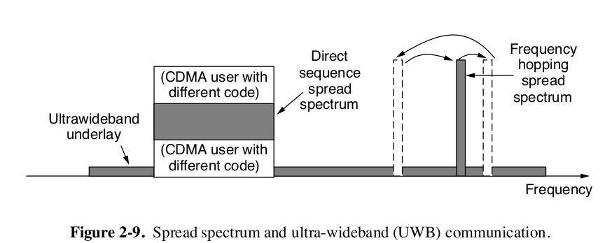

**Ultra-Wideband Communication**

* c